**COSC 385.001 – Automata**

**Spring 2018**

**Project 4**

**Due: Wednesday, April 25, 2018, 03:00 PM**

**Problem-12**

**Student: Jose Dixon**

**Instructor: Vojislav Stojkovic**

**Points: 15**

**Part II.**

**12. one’s_complement(x); x is a binary number**

**Part III.**

We are now familiar with the basics of various number systems used in digital electronics. Now let us quickly look through the main number system which is binary number system. In binary number system 0 and 1 can represent all the numbers. Before discussing about 1's complement let us first look at some different things.  
Let us look through the numbers from 0 to 7

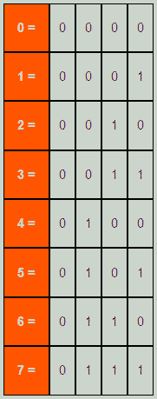

Now we have given this as an example to illustrate the representation of binary numbers. This is done to represent the positive numbers. But what if we want to represent the negative numbers in binary number system.

The concept of negative sign is not there in binary number system. Although there have been disputes about representing negative numbers in binary number system. And for it various methods have been developed. The most popular of them all are 1's complement and 2's complement. Though 2's complement dominates the 1's complement in popularity but this is also used because of somewhat simpler design in hardware due to simpler concept. Now we will look at the method of 1's complement.

Number Representation

1's complement is a very easy method for representing negative numbers in binary number system. To represent any number which is negative first we have to consider the binary value of its positive magnitude in binary system, then we have to simply convert the 1’s with 0 and the 0s with 1 and we will get the 1's complement of that number which is also the negative value of that number. As we can see that this method is truly a method of complementing. We will have a clear idea if we look at some examples.

Example  
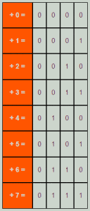

First let us consider the positive numbers from 0 -7

Now the 1's complement of these numbers will be like as follows 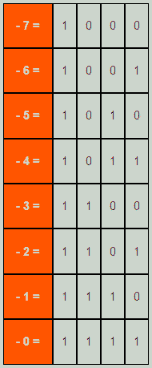

**Part IV.**

**Code**

//LOAD AN EXAMPLE TO TRY

//then load an input and click play

//Syntax:

//-------CONFIGURATION

name: Jose-CS385-P4: One's complement

init: q0

accept: q3

//-------DELTA FUNCTION:

q0,0

q1,1,>

q0,1

q1,0,>

q1,0

q1,1,>

q1,1

q1,0,>

q1,_

q2,_,<

q2,0

q2,0,<

q2,1

q2,1,<

q2,_

q3,_,>

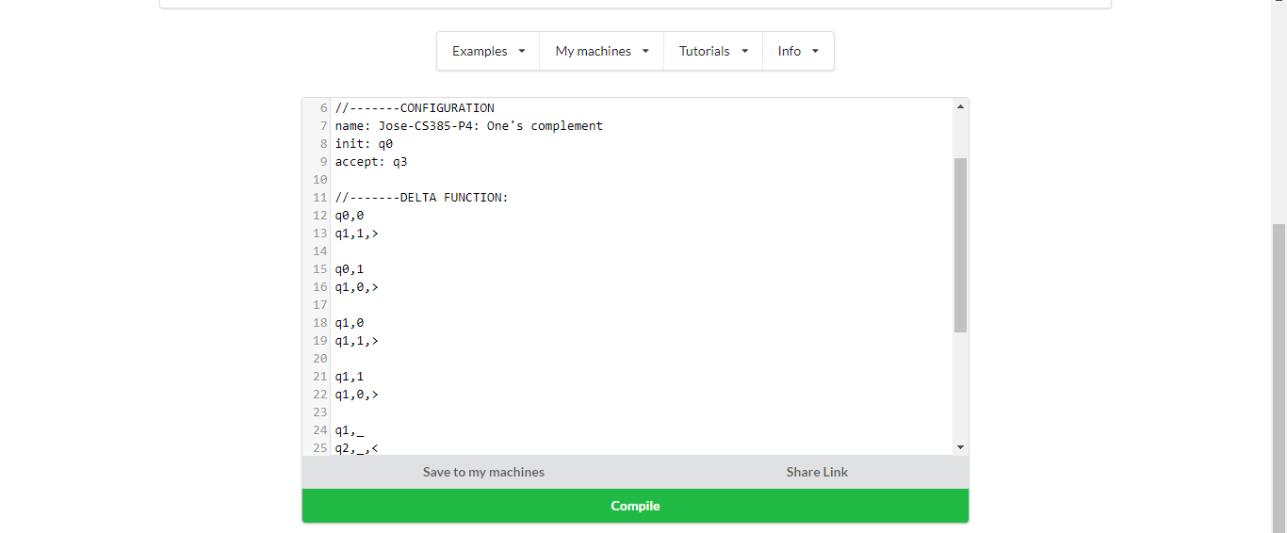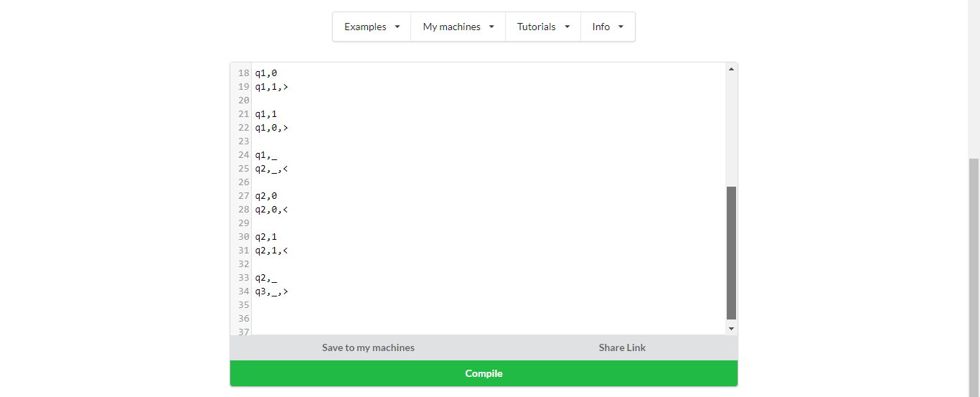

**Part V.**

**Test Examples**

**Test Example 1**

Input

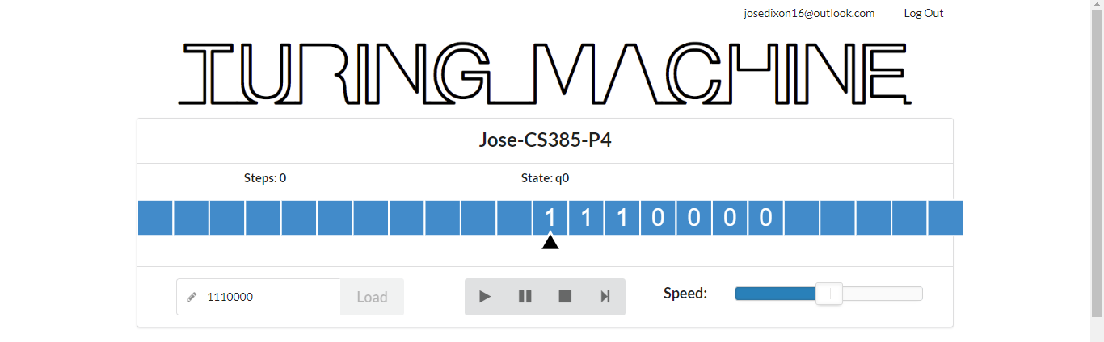

Output

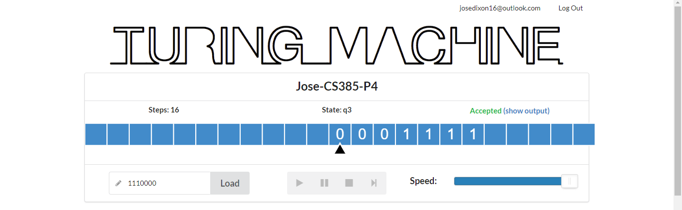

**Test Example 2**

Input

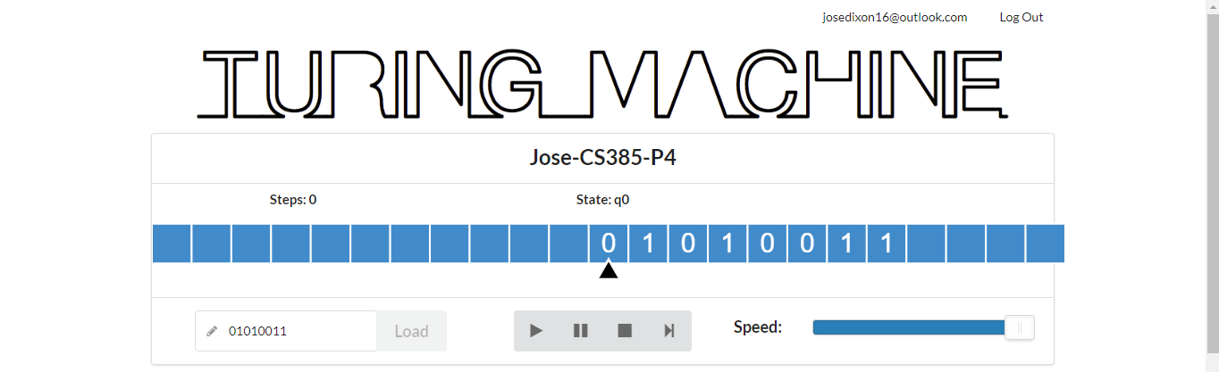

Output

